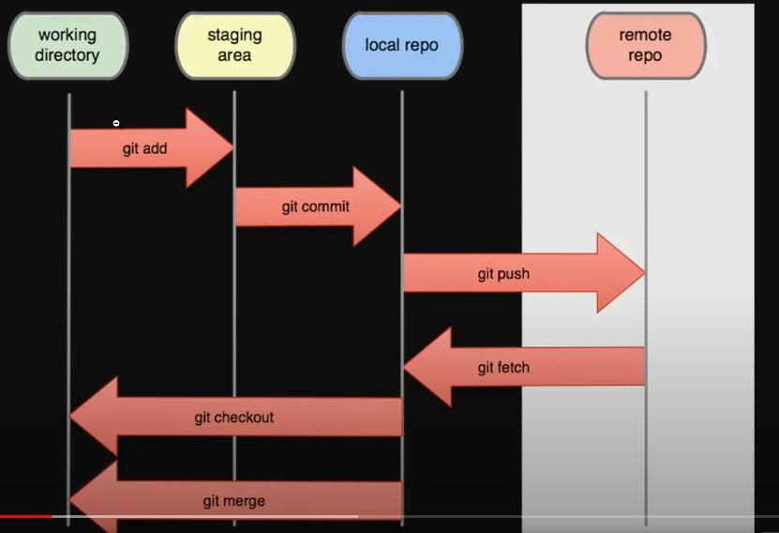**Git & GitHub**

|  |  |
| --- | --- |
| **Command** | **Function** |
| git init | Initializes a new Git repository |
| git clone <url> | Clones a remote repository to your local machine |
| git add <file> | git add * | Adds changes to the staging area | Add all the files |
| git commit -m "message" | Commits the changes in the staging area to the repository |
| git status | Shows the status of the working directory |
| git log | Displays the commit history |
| git pull | Fetches and merges changes from a remote repository |
| git push | Pushes local commits to a remote repository |
| git branch | Lists all branches in the repository |
| git checkout <branch> | Switches to a specific branch |
| git merge <branch> | Merges changes from one branch into the current branch |
| git remote -v | Lists all remote repositories and their URLs |
| git fetch | Downloads objects and refs from another repository |
| git reset <file> | Unstages changes for a file |
| git reset --hard <commit> | Resets the repository to a specific commit |
| git stash | Stashes changes in a dirty working directory |
| git diff | Shows the changes between the working directory and staging |
| git remote add <name> <url> | Adds a new remote repository |
| git rm <file> | Removes a file from the working directory and staging |
| git config <option> <value> | Sets configuration options for Git |

# **1) Configuration**

* Set your name:

**>> git config --global user.name "Your Name"**

* Set your email:

**>> git config --global user.email** [**youremail@example.com**](mailto:youremail@example.com)

* Set your preferred text editor (e.g., for commit messages):

**>> git config --global core.editor "vim"**

* List all your current Git configurations:

**>> git config –list**

* Set an alias (e.g., 'lg' for a pretty log output):

**>> git config –global alias.<abrev> ‘word that you want to abbreviate’**

**Example:**

make an alias 'g' to 'git'

>> git config --global alias.g 'git'

# **2) Public Key**

To set a public Key write the following command

**>> ssh-keygen -t rsa**

Set password🡪 view the public key

**>> cat ~/.ssh/id_rsa.pub**

Copy it and add it to your account (setting🡪security🡪SSH🡪Create New SSH key)

- test your SSH connection to GitHub using:

**>> ssh -T git@github.com**

# **4) Branching**

* Create a new branch:

**>> git branch <branch_name>**

* Switch to a branch

**>> git checkout <branch_name>**

* Creating and switching to a new branch in one step

**>> git checkout -b <branch_name>**

* Listing all branches in the repository

**>> git branch**

**>> git branch -a** #list all branches regardless of the relation between them.

* Merging changes from one branch into another:

**>> git merge <branch_name>**

* Deleting a branch (after merging or if no longer needed):

**>> git branch -d <branch_name>**

# **5) stash**

* Stash the changes

**>> git stash**

* List stashed changes

**>> git stash list**

* Stash changes with a custom name instead of (stach@{#})

**>> git stash save "Custom Name"**

* pop the most recent stash and remove it from the stash list

**>> git stash pop**

**>> git stash pop stash@{1}** # pop a specific stash

* Apply🡪 same as pop but without removing it from the stash list

**>> git apply**

**>> git apply stash@{1}** # Apply a specific stash

* Show changes in the most recent stash

**>> git stash show**

**>> git stash show stash@{1}** # show changes in a specific stash

* Clear all stashed changes

**>> git stash clear**

# **Reset the Head**

# **Ignore File or Directory**